stp & etherchannel TUNNING pROJECT

A portfolio project by ABDUSSAMAD ALHASSAN

[**LinkedIn**](http://www.linkedin.com/in/abdussamad-alhassan) Profile

x.com/grndmaster_

Table of Contents

Tables 2

Executive Summary 3

1.1 Design Objectives 3

1.2 Network Components 3

1.3 Implementation Overview 3

Network Topology 4

2.1 Topology Diagram 4

2.1.1 Physical Topology 4

2.1.2 Logical Topology 4

2.2 Core Network Components 5

2.2.1 Core Switches (SW1, SW2, SW3) 5

2.2.2 Routers (R1 and R2): 5

2.2.3 Virtual Private Clouds (VPCs) 5

2.3 Interconnectivity 5

2.3.1 Layer 2 Connectivity 5

2.3.2 Trunking 5

2.4 High Availability and Redundancy 6

2.5 Security and Management 6

2.6 DHCP Management 6

Device Inventory 7

2.1 Core Switches 7

2.2 Routers 7

2.3 Virtual PC Simulator (VPC) 7

2.4 Summary of Interface Configurations and Connections 8

Network Configurations 10

Router Configurations 10

# Tables

Table 1. Core Switches table 6

Table 2 Routers Table 6

Table 3 VPCs 7

# Executive Summary

This document outlines the design and implementation of a robust networking solution for a simulated enterprise environment, aimed at showcasing my technical expertise and practical skills in network engineering. The network is structured around three core components: core switches (SW1, SW2, and SW3), routers (R1 and R2), and Virtual Private Clouds (VPCs) equipped with DHCP services to facilitate dynamic IP address allocation.

## 1.1 Design Objectives

The primary objective of this networking project is to create a highly available and scalable infrastructure that ensures seamless connectivity across multiple branches while implementing redundancy protocols to enhance network reliability. The configuration leverages industry best practices, including:

1. Layer 2 Switching: Utilizing VLANs and Port Channels to optimize traffic flow and improve network performance.
2. First Hop Redundancy Protocol (FHRP): Implementing GLBP (Gateway Load Balancing Protocol) on routers R1 and R2 to ensure high availability and load balancing for IP address allocation.
3. Dynamic Host Configuration Protocol (DHCP): Enabling DHCP on VPCs 4, 5, and 6 to simplify IP address management and improve network efficiency.

## 1.2 Network Components

1. Core SwitchesConfigured to support trunking and VLAN segmentation for effective traffic management across different network segments.
2. Routers (R1 and R2): These devices serve as the gateway for internal traffic to external networks, equipped with GLBP for enhanced fault tolerance.
3. Virtual Private Clouds (VPCs): Each VPC is configured with DHCP to provide dynamic IP address allocation for connected devices, improving usability and minimizing administrative overhead.

## 1.3 Implementation Overview

The network infrastructure is configured using Cisco IOS, showcasing the following features:

1. Redundant Paths: By implementing GLBP and Port Channels, the network can maintain uptime and performance even during hardware failures.
2. IP Address Management: The DHCP configurations streamline the process of assigning IP addresses, ensuring efficient utilization of available address space.
3. Security Measures: Standard security practices have been applied, including disabling unused ports and ensuring appropriate access controls.

# Network Topology

This section details the network topology implemented for the simulated enterprise environment. The design is structured to optimize performance, reliability, and scalability while ensuring effective communication between different network segments.

## 2.1 Topology Diagram

### 2.1.1 Physical Topology

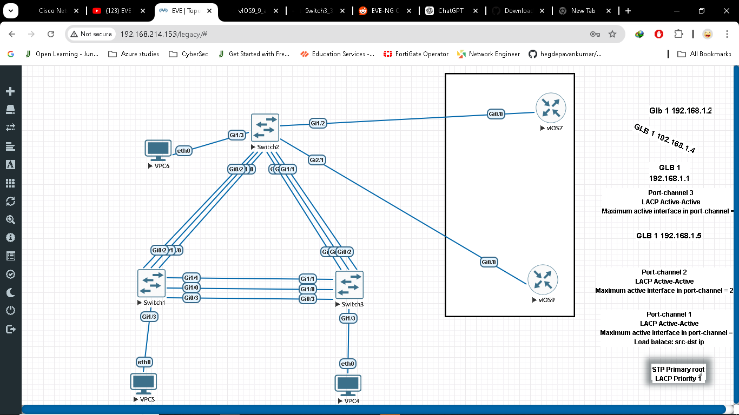

Figure Physical topology

### 2.1.2 Logical Topology

Logical Topology focuses on how devices communicate with each other, the protocols used, and the logical connections between devices, including link aggregation technologies like EtherChannel for redundancy and spanning tree for loop prevention. It illustrates the logical flow of data and the relationships between network components.

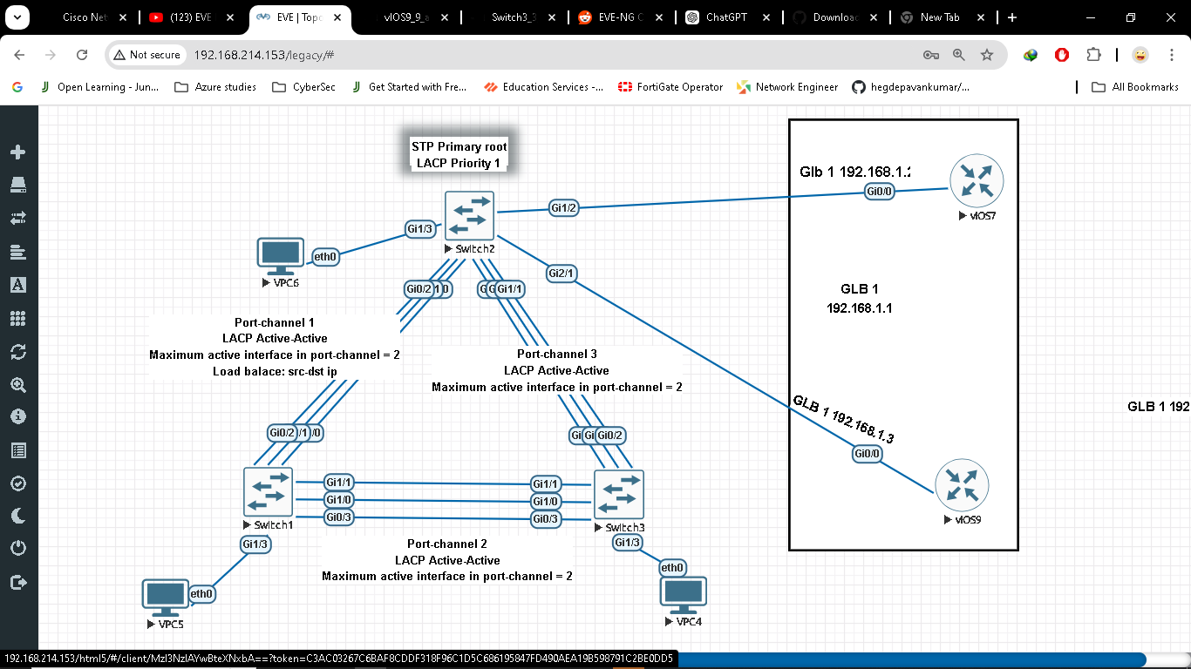

Figure . Logical Topology

## 2.2 Core Network Components

2.2.1 Core Switches (SW1, SW2, SW3):

* These switches form the backbone of the network, facilitating high-speed connectivity between various segments.
* They support VLAN segmentation, enhancing traffic management and security.

### 2.2.2 Routers (R1 and R2):

* Responsible for routing traffic between different VLANs and external networks.
* Configured with Gateway Load Balancing Protocol (GLBP) to provide redundancy and load balancing for IP address allocation.

### 2.2.3 Virtual Private Clouds (VPCs)

VPCs 4, 5, and 6:

* Each VPC is equipped with DHCP services to dynamically allocate IP addresses to connected devices.
* They provide isolated environments for testing and development purposes.

## 2.3 Interconnectivity

### 2.3.1 Layer 2 Connectivity

Port Channels are configured on the core switches, allowing multiple physical links to be aggregated into a single logical link, improving bandwidth and providing redundancy.

### 2.3.2 Trunking

VLANs are extended across the switches using trunking protocols (802.1Q), allowing for the transmission of traffic from multiple VLANs over a single physical link.

## 2.4 High Availability and Redundancy

First Hop Redundancy Protocol (FHRP)

GLBP is implemented between routers R1 and R2, ensuring that in the event of a failure, network traffic can be seamlessly rerouted, maintaining uninterrupted connectivity.

## 2.5 Security and Management

Access Control:

Unused switch ports are disabled to prevent unauthorized access and enhance network security.

## 2.6 DHCP Management

The DHCP configuration on VPCs streamlines IP address management, minimizing the potential for conflicts and ensuring efficient utilization of the address space.

# Device Inventory

The following section outlines the devices deployed in the network topology, including their specifications, roles, and configurations. This inventory provides a comprehensive overview of the hardware and software resources utilized within the network environment for portfolio practice.

## 2.1 Core Switches

Table . Core Switches table

|  |  |  |  |
| --- | --- | --- | --- |
| Device Name | Model | Role | Configuration Highlights |
| SW1 | Cisco Catalyst 9300 | Core Switch | Supports VLANs, Port Channels, and STP configurations. | |
| SW2 | Cisco Catalyst 9300 | Core Switch | Spanning tree primary root  LACP System priority 1  Acts as an aggregation point for downstream devices and implements redundancy. |
| SW3 | Cisco Catalyst 9300 | Core Switch | Configured for trunking, VLAN management, and Port Channels |

## 2.2 Routers

|  |  |  |  |
| --- | --- | --- | --- |
| Device Name | Model | Role | Configuration Highlights |
| vIOS9(R1 ) | Cisco ISR 4000 | Primary Router | Configured with GLBP for redundancy, DHCP server, and IP routing. |
| vIOS7 (R2) | Cisco ISR 4000 | Secondary Router | Configured with GLBP and IP routing, supporting failover scenarios |

Table Routers Table

## 2.3 Virtual PC Simulator (VPC)

|  |  |  |
| --- | --- | --- |
| Device Name | Model | Configuration Highlights |
| VPC 4 | DHCP-enabled VPC | Dynamic IP address allocation for connected devices. |
| SW2 | DHCP-enabled VPC | Provides an isolated environment for testing and development |
| SW3 | DHCP-enabled VPC | Supports dynamic IP addressing and VPC segmentation. |

Table VPCs

## 2.4 Summary of Interface Configurations and Connections

|  |  |  |  |  |
| --- | --- | --- | --- | --- |
| Device Name | Interface Name | Configuration details | Connected to | Notes |
| SW1 | Port channel 1  (G0/0-2) | LACP active mode.  Maximum active interfaces in channel:2.  Trunk Mode  Allowed vlans 1-20. | SW2 Port channel 1(G0/0-2) | Aggregates connections from access switches. |
| SW1 | Port channel 2  (G1/0-1, G0/3) | LACP active mode.  Maximum active interfaces in channel:2.  Trunk Mode  Allowed vlans 1-20 | SW3 Port channel 2 (G1/0-1, G0/3) | Aggregates connections from access switches |
| SW2 | Port channel 1  (G0/0-2) | LACP active mode.  Maximum active interfaces in channel:2.  Trunk Mode  Allowed vlans 1-20 | SW1 Portchannel 1 (G0/0-2) | Aggregates connections from access switches |
| SW2 | Port-channel 3  (G1/0-1, G0/3) | LACP active mode.  Maximum active interfaces in channel:2.  Trunk Mode  Allowed vlans 1-20 | SW3 Port-channel 3  (G0/0-2) | Aggregates connections from access switches |
| SW3 | SW3 Port channel 2 (G1/0-1, G0/3) | LACP active mode.  Maximum active interfaces in channel:2.  Trunk Mode  Allowed vlans 1-20 | SW 2 Port-channel 3  (G1/0-1, G0/3) | Aggregates connections from access switches |
| SW3 | Port-channel 3  (G0/0-2) | Maximum active interfaces in channel:2.  Trunk Mode  Allowed vlans 1-20 | Port-channel 3  (G1/0-1, G0/3) | Aggregates connections from access switches |
| vIOS9(R1) | GigabitEthernet0/0 | GLBP configured,  Interface IP 192.168.1.3 | SW2 GigabitEthernet1/2 | Provides redundancy with GLBP |
| vIOS7(R2) | GigabitEthernet0/0 | GLBP configured,  Interface IP 192.168.1.2 | SW2 GigabitEthernet2/1 | Provides redundancy with GLBP |